Clue: Transcription  This process makes mRNA!  Code: mRNA | Clue: Translation  This process makes proteins!  Code: protein
Clue:  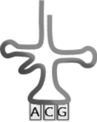  Code: What is the anticodon of the above tRNA molecule? (That’s your code!) | Clue:  Met-Leu-Gly-Leu-Gly-Pro- Met-Pro  _______ bonds join amino acids together to form proteins.  Code: fill in the blank to find your code!
Clue:    An Amino Acid  Code: monomer | Clue:  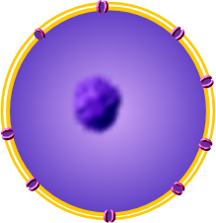  Nucleus  Code: Nucleic Acids
Clue:  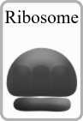  Code: Protein Factory | Clue:  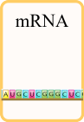  Code: 3 nitrogen bases on mRNA code for one amino acid. These 3 letters make up one _________.

<a href="https://www.freepik.com/free-vector/cartoon-set-medieval-castle-doors-white_38920003.htm#fromView=search&page=1&position=12&uuid=9deccfbb-de5f-4228-ac28-aa74ae98b2d6">Image by upklyak on Freepik</a>

<a href="https://www.freepik.com/free-vector/old-metal-padlocks-isolated-white-background-symbol-safety-privacy-security-realistic-set-open-closed-rusty-locks-heart-shape-with-scratches_10308153.htm#fromView=search&page=1&position=18&uuid=35f18566-03fc-4a49-8693-46cd1aaf2468">Image by upklyak on Freepik</a>

